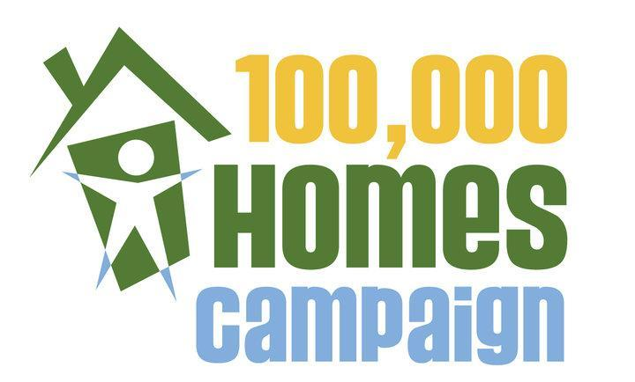

Dear Community Partner:

As you know, the Department of Family and Support Services, the Chicago Alliance to End Homelessness, and the Corporation for Supportive Housing carried out a weeklong effort in August 2010 to identify and help persons who are homeless obtain and sustain permanent housing in partnership with Community Solutions’100,000 Homes Campaign. Currently, we are working to match vulnerable homeless individuals and families surveyed during Registry Week to supportive housing units through our Systems Integration Teams. We are asking for your continued support and commitment to help Chicago continue to house vulnerable persons through ongoing efforts of the Campaign, and demonstrate the effectiveness of a coordinated path to housing.

The 100,000 Homes Campaign is a grassroots effort to find and place the most vulnerable, long-term homeless individuals and families into permanent supportive housing across the country by July 2013. The objective of Chicago 100,000 Homes Campaign is to continue to identify and house those prioritized according to medical vulnerability. As current systems integration efforts have thus far demonstrated, a variety of available permanent supportive housing options is needed to best match individuals and families with units.

We also expect that this effort will increase the number of chronically homeless individuals in permanent housing, which is a national goal that we report to HUD annually. We have done well at meeting our goals, mainly because we have received resources targeted to this population. Yet in non-targeted units, there still may be challenges in connecting individuals and families who are eligible for your programs and who are in most need for supportive housing. We hope that a common assessment and database will improve this connection and help to mitigate challenges.

Please complete the attached survey that will tell us what resources you believe can be made available for this effort, and also what you need to supplement your efforts. All commitments will be announced publicly during press conferences, web-postings, and other literature about the initiative and you will be listed as a Campaign Supporter.

Sincerely,

Betsy Benito, Department of Family and Support Services
Liz Drapa, Corporation for Supportive Housing
Nancy Radner, Chicago Alliance to End Homelessness

Can your agency commit housing and/or service resources to the 100,000 Homes Campaign?

- How many permanent supportive housing units targeted to homeless people does your agency manage?

- How many units do you expect will become vacant or available for occupancy between Insert appropriate dates? Please indicate single v. family units.

- How many units do you expect to become vacant in Insert appropriate date?

- How many of these units would you be willing to fill from people identified through the Vulnerability Index Survey that are determined to meet your program eligibility? Please clarify the number of referrals you would be willing to take in Insert appropriate dates.

More about your program:
- Do you have a waiting list?

- Do you have a formal tenant selection plan that governs the waiting list?

- Would you be interested or willing to have the tenant selection plan modified to support the Registry?

- How might you be able to incorporate vulnerable persons from the Registry with existing clients on your waiting list?

- Who is your target population and what are your entrance criteria used to determine eligibility?

- For what length of time do you hold a unit for an approved client?

- What services does the program provide to residents? How intensive are the services?

- What additional services would need to be attached to the persons identified through registry beyond what your agency currently provides?

- Please state other resources your agency would require to meet the service needs of housing this population.

Please return this form to Betsy Benito, Director-Illinois Program, Corporation for Supportive Housing - Illinois, betsy.benito@csh.org. If you have any questions, please contact Betsy Benito, 312-332-6690x14 or Madeline Shea, 312-332-6690x24.

