Waterloo Region – Registry Week for 20,000 Homes

Social Media Calendar #20kHomes
Date | Tweet | Metrics
Nov. 25 | 20,000 Homes Campaign: Communities across Canada housing vulnerable ppl who are homeless. @RegionWaterloo is 1st pilot community! #20kHomes | - 9 retweets  - 4 favourites
Nov. 26 | The Cdn #20kHomes Campaign was inspired by the U.S. #100kHomes Campaign. http://bit.ly/11SLO1l Video: http://bit.ly/1xSkFaT | - 2 retweets  - 1 favourite  - 3 Bitly clicks
Nov. 27 | Almost 3,500 people experienced homelessness in Waterloo Region last year. Get more local data here: http://bit.ly/1vt82Do #20kHomes  Poverty impacts homelessness in Waterloo Region. Read common myths about poverty: http://bit.ly/1Ao74dx #20kHomes | - 16 retweets  - 1 favourite  - 25 Bitly clicks  - 17 retweets  - 4 favourites  - 9 Bitly clicks
Nov. 28 | Managing homelessness by providing emergency services is much more expensive than providing housing #20kHomes Graphic  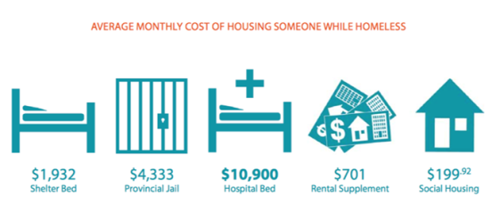  Infographic reference: Stephen Gaetz, Jesse Donaldson, Tim Richter, & Tanya Gulliver (2013): The State of Homelessness in Canada 2013. Canadian Homelessness Research Network Press.  Re | - 27 retweets  - 6 favourites
Nov. 29 | .@RegionWaterloo developed OOTC closure response plan to support ppl experiencing homelessness: http://bit.ly/1xXb5TO #20kHomes | - 3 retweets  - 1 favourite  - 17 Bitly clicks
Nov. 30 | Today: last volunteer training session before teams survey ppl experiencing homelessness. http://bit.ly/1C5FHXr #20kHomes | - 6 retweets  - 4 favourites  - 32 Bitly clicks
Dec. 1 | Survey teams were out bright and early this morning surveying ppl who are homeless – part of @RegionWaterloo community registry. #20kHomes | - 5 retweets
Dec. 2 | Community Debrief tomorrow will share results of community registry. Local stats on homeless population. #20kHomes http://bit.ly/1vLOxDP | - 2 retweets  - 1 favourite  - 10 Bitly clicks
Dec. 3 | Join us @ 150 Frederick St., 10am TODAY for community registry debrief. Interesting data on @RegionWaterloo homeless population #20kHomes.  Great turnout for @RegionWaterloo #20kHomes community debrief! Ken Seiling brings greetings.  Canadian Alliance to End Homelessness on Wloo Region: "You're the pioneers of the #20kHomes campaign." 30 more communities have signed on.  Miss the @RegionWaterloo #20kHomes community debrief? See the presentation here: http://tinyurl.com/WRRegistryWeekDebrief  .@RegionWaterloo sets goal to house 40 of our most vulnerable homeless over winter 2014/15. #WRawesome #20kHomes | - 1 retweets  - 2 retweets  - 1 favourite  - 2retweets  - 2 retweets  - 1 favourite  - 11 retweets  - 2 favourite
Dec. 4 | Thanks to all our volunteers for a great #20kHomes campaign. See the results here: http://tinyurl.com/WRRegistryWeekDebrief #20kHomes  Volunteer opportunities to help end homelessness in Waterloo Region: http://bit.ly/1z8tThJ #20kHomes | - 1 retweet  - 8 retweets  - 2 favourites  - 33 Bitly clicks
Dec. 9 | #20kHomes campaign was an eye-opening experience for our volunteers. Watch a short video on @RegionWaterloo Registry Week: http://bit.ly/1yyBgNB | - 6 Bitly clicks  - 80 Youtube views

Read on for more…

#20kHomes tweet samples
